ABSTRACT
Data migration to a cloud computing environment is in many ways an exercise in risk management. Both qualitative and quantitative factors apply in an analysis. Since service providers typically do not have access to the physical security system of data centers, they must rely on the infrastructure provider to achieve full data security. Even for a virtual private cloud, the service provider can only specify the security setting remotely, without knowing whether it is fully implemented. Cloud Migration is one of much conversed point where cloud managers face extreme problems at the time of data migration from a one company’s server to a other company’s server that forms cloud elsewhere. If data migration is not done systematically and properly, it can give rise to problems concerning data and cloud security of company’s assets that primarily comprise of data.
Example: Suppose an XYZ company wants to shift its data to cloud storage of other for increased uptime and scalability, it goes to cloud service provider for performing such functions. Now, the cloud provider starts initializing steps for data transfer to other cloud, but in between face problems like data crash or unauthorized access by third parties. This is where the problem lies. The proprietor of data that hired cloud manager would not only face reputation losses but also monetary losses. Similar case was experienced when Amazon cloud failure happened and several businesses suffered immense losses due to it.
Thus, securing data remains an utmost priority of cloud managers to prevent global cloud security threats that also include cross-border security concerns

Contents
1 Introduction 4
1.1 Motivation 4
1.2 Scope 6
1.3 Objectives 9
2 Literature Review 10
3 System Analysis and Design 15
4 Preliminary Results 17
5 Conclusion and Future Work 18
6 Bibliography 19

List of Figures
Fig 1: Cloud interoperability motivation 5
Fig 2: Growth of Cloud computing 6
Fig 3: NIST Cloud architecture 15

CHAPTER 1

INTRODUCTION

1.1MOTIVATION
Motivation towards Cloud in recent time Cloud computing is not a new idea but it is an evolution of some old paradigm of distributed computing. The advent of the enthusiasm about cloud computing in recent past is due to some recent technology trend and business models.
1. High demand of interactive applications – Applications with real time response and with capability of providing information either by other users or by nonhuman sensors gaining more and more popularity today. These are generally attracted to cloud not only because of high availability but also because these services are generally data intensive and require analyzing data across different sources.
2. Parallel batch processing – Cloud inherently supports batch-processing and analyzing tera-bytes of data very efficientlyopen source counter partHadoopcan be used to do these hiding operational complexity of parallel processing of hundreds of cloud computing servers.
3. New trend in business world and scientific community – In recent times the business enterprises are interested in discovering customer needs, buying patterns, supply chains to take top management decisions. These require analysis of very large amount of online data. This can be done with the help of cloud very easily. Yahoo! Homepage is a very good example of such thing. In the homepage they show the hottest news in the country. And according to the users’ interest they change the ads and other sections in the page. Other than these many scientific experiments need very time consuming data processing jobs like LHC (Large Hadron Collider).
4. Extensive desktop application – Some desktop applications like Matlab, Mathematica are becoming so compute intensive that a single desktop machine is no longer enough to run them. So they are developed to be capable of using cloud computing to perform extensive evaluations.

Cloud computing has already provided considerable capabilities for scalable, highly reliable, and easy to deploy environment for its clients. Nevertheless, the benefits of interconnected Cloud environments for both Cloud providers and their clients are numerous and there are essential motivations for Cloud interoperability, which will eventually lead to the Inter-Cloud. The key benefits of an Inter-Cloud environment are Scalability and Wider Resource Availability.Interoperability and Avoiding Vendor Lock-in Availability and Disaster Recovery Cloud.
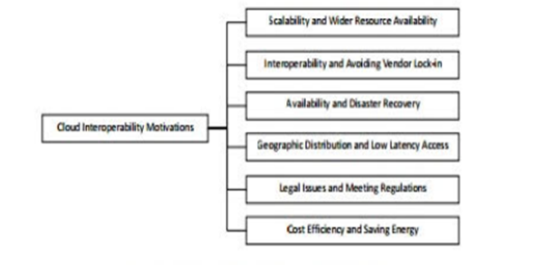

1.2 SCOPE
Cloud computing is a convenient, on-demand model for network access to a shared pool of configurable computing resources (e.g., networks, servers, storage, applications, and services) that can be rapidly provisioned and released with minimal management effort or service provider interaction. Conceptually it refers to a model of scalable, real-time, internet-based information technology services and resources, satisfying the computing needs of users, without the users incurring the costs of maintaining the underlying infrastructure.
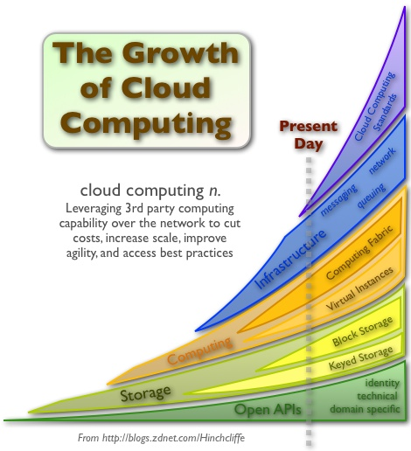
A great appeal of the cloud is the potential to create new solutions in the future that were not technically or economically feasible without the use of cloud services. Keeping in view the above; Imagine you are living in year 2025, and going to lunch with a former colleague in your new flying car. The two of you wonder, “Whatever happened to cloud computing?”
As a buzzword, like buzzwords of the past, cloud computing will eventually be baked into all our technology and barely discussed as a concept. Cloud computing in 10 years will have gone off in various directions, all systemic to how we handle enterprise computing in the future. Here are just two paths:
In 10 years, pervasive cloud services will be the standard for assembling business solutions. We will leverage core services that either exist within our enterprise or from public cloud providers to assemble and reassemble business solutions. These services will be utility-based, perhaps primitive storage and compute or security and governance or more sophisticated business uses, such as market forecasting services.
While services certainly reside in the clouds today, in 10 years, they should be built around the same set of standards and thus be more compatible, no matter which public provider you leverage. Moreover, they should be dynamically discoverable and self-healing, and they may exist as private services you own and maintain. Alternatively, they could be public services you leverage from any public cloud provider.
In 10 years, cloud-based data will include context to better understand that data. Data today exists largely in cloud, which makes it difficult to access and difficult to gather for business intelligence. As more data moves to the cloud, enterprises will understand how to holistically leverage this information using the ability to instantly query petabytes of private business findings using data services. We’re already on this path today with the big data movement.

1.3 Objectives
- Protect Postal Service data from unauthorized access, disclosure, modification, and monitoring. This includes supporting identity management such that the Postal Service has the capability to enforce identity and access control policies on authorized users accessing cloud services. This also includes the ability of the Postal Service to allow access to its data selectively available to other users.
- Protect information resources from supply chain threats. This includes verifying and maintaining the trustworthiness and reliability of the CP, as well as the security assurances associated with the hardware and software used.
- Prevent unauthorized access to cloud computing infrastructure resources. This includes implementing security domains that have a logical separation between computing resources (e.g., logical separation of Postal Service workloads running on the same physical server by virtual machine (VM) monitors [hypervisors] in a multitenant environment) and using default to no-access configurations.
- Implementing data-migration compatibility tool, to check the compatibility between the clouds and also enabling the data migration between the cloud.

CHAPTER 2

LITERATURE REVIEW
Cloud computing can be regarded to a certain degree, as the evolution of grid computing. Such a close relationship has caused confusion. The grid framework is originally driven by scientific purposes, and aimed at coordinating resources that are not subject to centralised control under standard, open, general-purpose protocols and interfaces.Cloud computing is born for commercial purposes and naturally service oriented. It is based on centralised data centres. The protocols and interfaces used may not be the same across clouds providers. 20th Australasian Conference on Information Systems Melbourne Yang & Tate 808 Cloud computing has completely distinct business model. It offers clear SLAs and is based on a “pay per use” pricing model. Grid computing on the other hand is based on a sharing system, that is, one needs to join the grid and contribute computing power to gain access to the computing power of other members. In this co-operative model, SLAs are not required or enforceable. In this paper, we see cloud computing is based on a large pool of easily usable and accessible virtualisedThese resources are typically built in centralised data centres and are dynamically re-configured to achieve an optimum utilization. Clouds are provided by a pay-as-you-go model in which guarantees are offered by the providers by means of customized SLAs This turns computing power into a public utility which will bring a profound paradigm shift to the IT industry and even to society as a whole. Cloud computing has promised many technological and sociological benefits. The computing power is generated from highly centralised and standardized data centres which contain up to millions of servers, with a considerable economy of scale. From an enterprise standpoint, cloud computing can deliver on-demand computing power at a very low if not any cost of the upfront infrastructure and ongoing maintenance. Cloud computing also promises to provide better performance, reliability and scalability. There is some evidence that these are being delivered.
From an environmental standpoint, owing to the advanced electrical and cooling systems used by its centralised data centres, cloud computing has promised to bring low environmental cost and high energy efficiency, compared to the traditional scattered enterprise data centres. All in all, these promises have drawn drastically increasing attention of a world wide scale.

2.1 Virtualization Layer Network Stability
Cloud computers must operate on some sort of virtualization technology for many of the following features to even be feasible. But as general purpose computing moves from dedicated hardware to on-demand computing, one key feature of the dedicated model for web applications is a stable, static IP address. If the virtualization layer borks when the cloud has recovered the cloud instances of compute, the developer should be able to rely on the web application just working without having to re-jigger network settings.

2.2 API for Creation, Deletion, Cloning of Instances
Developers should be able to interact with the cloud computer, to do business with it, without having to get on the phone with a sales person, or submit a help ticket. In other words, the customer should be able to truly get on-demand computing when they demand, whenever they demand. Joyent only began to offer this recently through Aptana and their Aptana Studio product. However, the API is only available to Aptana at this point. The API needs to be publicly available to everyone. Provide a credit card that works and is your and you should get compute, storage, and RAM on-demand. The challenges for cloud computing companies is to figure the just-in-time economics that allow us to provide on-demand infrastructure without having lots of infrastructure sitting around waiting to be used. I think this means that cloud computing companies will, just like banks, begin more and more to “loan” each other infrastructure to handle our own peaks and valleys, But in order for this to happen we’d need the next requirement.

2.3 Application Layer Interoperability
Cloud computers need to support a core set of application frameworks in a consistent way. We propose that cloud computers should support PHP, Ruby, Python, Java and the most common frameworks, libraries, gems/plugins, and application/web servers for each of these languages. Essentially, a developer should be able to move between Joyent, the Amazon Web Services, Google, Mosso, Slicehost, GoGrid, etc. by simply pointing the deploy gun at the cloud having used the API mentioned above to spin up instances and go. Change DNS, done. But, no cloud computing company is innovating by providing better application layer solutions. We ought to support the most popular languages and move on. However, for a developer to truly have cloud portability, we need to support another requirement.

2.4 State Layer Interoperability
This is the most difficult problem to solve when scaling a web application, and, consequently, the area in which cloud computing companies are innovating while sacrificing interoperability. It’s not simply a question of deciding that we should all support MySQL or Postgres because we will find that the needed requirement “Automatic Scaling” is practically impossible to achieve with these tools. Amazon is innovating with SimpleDB, Google has BigTable as solutions for the problem, but developers can’t leave either cloud because neither SimpleDB nor BigTable are available anywhere else. What is needed, and I’m looking ahead to the next requirement when I say this, is an XMPP-based state-layer that can flush out to some SQL-y store. Think open-source Tibco. The financial markets fixed these problems years ago. This datastore needs to speak SQL, be built using open-source and free software, and be easy for developers to adopt. The value cloud computing companies provide to developers is running the state layer for them, without requiring developers to use some proprietary state layer that may or may not provide scalability upon success and represents lock-in.

2.5 Application Services
A cloud computer should provide scaled application services consumable by developers in developing and delivering their own applications. There are two types of application services. The first group is delivered using open protocols/formats. Examples would be IMAP/SMTP, LDAP/vCARD, iCAL/ICS,XMPP, OpenID, OPML. All clouds should offer
these open protocols/formats so that developers can move between clouds without having to rewrite their application. The second group is delivered as web services, are often proprietary to the cloud and include services such as payments, inventory.

2.6 Automatic Scale
All things being equal, a competent developer should be able to deploy to a cloud and grow to five billion page views a month without having to think about “scale”. Just write the code, the cloud computer does the rest.
Is this achievable today? NO. No cloud computer automatically scales applications. Part of the problem lies in the state layer. Part of the problem lies in what it means to scale. What is the measure of scale Responsiveness Scaling the state layer is a black art. Scaling the application layer or the static assets layer relies, in part on load balancing and storage.

2.7 Hardware Load Balancing
The cloud computer should provide the means to achieve five billion page views a month. I picked that number because it is big. If you’re writing an application, and you want to be able to achieve tremendous scale, the answer shouldn’t be to move off the cloud onto your own private cloud of dedicated servers. Of course, if the cloud computer is open as we’ve described, you can build your own cloud. It’s also true you can generate your own electricity from coal, if you want to bother. But why bother Software load balancers will get you nowhere close to the throughput required to achieve 5 billion page views per month. The state of the art is hardware load balancers.

2.8 Storage as a Service
Storage should be available to developers as a service. Where this is done today, it is done using a proprietary API and represents lock-in. The storage service should allow customers to consume endless amounts of storage and pay for only what is used. Objects on the storage service should be accessed by developers as objects rather than as nodes in a hierarchical tree. This way developers don’t have to understand the hierarchy.
WebDAV could be an open protocol version of the storage service, but fails to provide the abstraction of treating objects as objects rather than nodes in a hierarchical tree. At present, I don’t believe there is a reasonable solution to the problem that isn’t also proprietary. We need to develop one that is open and free.

2.9 “Root”, If Required
The cloud computer vendor can’t think of everything a developer or application might need or want to do. So the cloud needs to be hackable and extensible by the developer and that means an administrative account of some sort that allows the developer to shape and mold the cloud to their specific needs. By definition, cloud computers must be built on top of some sort of virtualization technology, so the developer never has “root” to the cloud, only “root” to the developer’s part of the cloud.

Chapter 3

System Analysis and Design

3.1 Hardware Requirement
- 80GB or more space in hard disk
- 1GB RAM or more
- 32Bit Processor or 64Bit
- Network connection with 1Mbps or more

3.2 Software Requirement
- Windows XP/7/8/8.1/10
- Eclipse
- Cloudsim
- AWS tool kit for eclipse

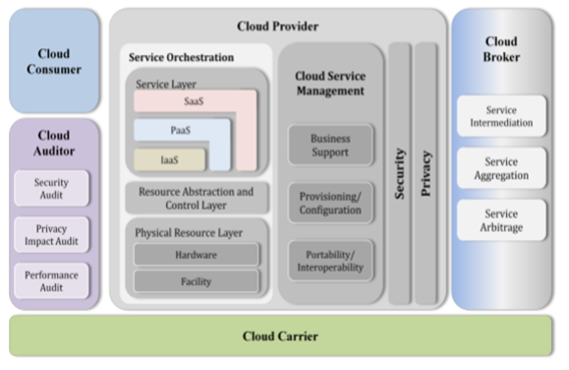

The above figure presents a high level view of the NIST Cloud Computing Reference Architecture (CCRA), which identifies the major actors (Cloud Consumer, Cloud Service Provider, Cloud Auditor, Cloud Broker, and Cloud Carrier), their activities and functions in cloud computing. A cloud consumer may request cloud services from a cloud provider directly or via a cloud broker. A cloud auditor conducts independent audits and may contact the others to collect necessary information.

Chapter 4

Preliminary Results

We went through different types of cloud services provided by various service providers and then we used Amazon EC2 Cloud to deploy a java application on it and made observations on
Uploading and storing application files.
Examination and storing of application metadata.
Creation of “droplet” for the application.
Selects an appropriate droplet execution agent (DEA) to run the droplet.
Starting the application.

Chapter 5

Conclusion and Future Work

The current version is draft and supports basic functionalities in implementing our application on the cloud platform and deploying it and also to integrate the inter-clouds that is deployed into a cloud. The proposed model integrates services to facilitate inter-cloud communication in a common platform in order to list all available services, instances, offer network capabilities, security and deployment of IaaS services. The experimental prototype demonstrates the basic configurations in order to develop an application and deploying it on cloud. Since this is an ongoing effort more information could be found. we focus on the development of the proposed model in order to include all services and components, and to develop a graphical user interface to provide a common management platform that will be offered as a service instance. In addition, extra effort will be made to the characterization of performance metrics in order to provide optimization algorithms. we aim to explore security issues and interoperability issues in order to optimize performance. Finally, we will explore other IEEE papers and APIs in order to expand the inter-cloud services.

Bibliography
[1]. A. Sheth and A. Ranabahu, "Semantic Modelling for cloud computing. Part I and II," IEEE
Internet Computing magazine vol 14, pp. pp 81-83, 2010.
[2]. J. McKendrick, "Does Platform as a Service have interoperability issues?," 24 May 2010.
Available: http://www.zdnet.com/article/does-platform-as-a-service-have-interoperability-
issues/.
[3]. D. Jamil and H. Zaki, "SECURITY ISSUES IN CLOUD COMPUTING AND
COUNTERMEASURES," International Journal of Engineering Science and Technology
vol 3 no 4, pp. pp 2672-2676, 2011.
[4]. T.G.PeterMell,"http://csrc.nist.gov/publications/nistpubs/800-145/SP800-145.pdf,"
september 2011. [Online].
[5]. A. V. Dastjerdi, S. G. H. Tabatabaei, and R. Buyya, "An Effective Architecture for
Automated Appliance Management System Applying Ontology-Based Cloud Discovery," in
Proceedings of the 10th IEEE/ACM International Symposium on Cluster, Cloud and Grid
Computing (CCGrid 2010), Melbourne, Australia, 2010.
[6]. c. Wang, k. Ren and Q. Wang, "Security Challenges for the Public Cloud," IEEE computer
society Issue No.01 - January/February (2012 vol.16), pp. pp: 69-73, 2012. Ghosh et al.,
International Journal of Advanced Research in Computer Science and Software Engineering
5(2), February - 2015, pp. 910-913 © 2015, IJARCSSE All Rights Reserved Page | 913
[7]. Hannay, J.E., Sjøberg, D.I.K.: A Systematic Review of Theory Use in Software Engineering
Experiments. Journal of IEEE Transaction on Software Engineering 33(2), 87–107 (2007)
[8]. Harauz, J., Kauifman, M., Potter, B.: Data Security in the world of cloud computing. IEEE
Security & Privacy 7(4), 61–64 (2009)
[9]. Takabi, H., Joshi, J.B.D.: Security and Privacy Challenges in Cloud Computing
Environments. Published. IEEE Security and Privacy 8(6), 24–31 (2010)

